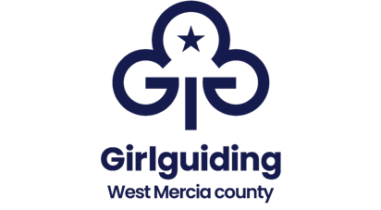
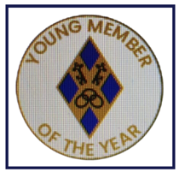
Girlguiding West Mercia
Young member of the year award

What is it for? | Exceptional service, achievement, or behaviour
Who can receive it? | Any young member of Girlguiding West Mercia up to their 19th birthday
Who can make recommendations? | Any member of Girlguiding West Mercia
Where do we get forms from? | Awards committee/ Girlguiding West Mercia website/ county office at Mercia Point
What is the selection procedure? | Nominations to be received by the County awards committee by 30 April

Please return the completed form to;

Chair of Awards, Girlguiding West Mercia, Mercia Point, Hordern Road, Wolverhampton, WV6 0HT
email: office@girlguiding-westmercia.org.uk

Girlguiding West Mercia
Young member of the year award

Nominations are for active young members of Girlguiding West Mercia. Any member can make a nomination.

Please complete in pen in block capitals

Candidate details

Name
Address, including postcode
Date of birth
Telephone number
Membership number (if known)
Section  * delete as applicable | Rainbow/Brownie/Guide/Ranger/  Young leader*
Unit
District
Division

Proposers details

Name
Email address
Telephone number
Address, including postcode
Membership number
Division (if applicable)
Relationship to the candidate

NOMINATION

Please give as much information as you can about why this young person should be considered for this award. Continue an additional sheet if necessary and attach any other supporting information/additional letters of support if you have them.

Please tell us about the young person, what they have done in guiding and why you feel they should have this award.
_____________________________________________________________________________________________________________________________________________________________________________________________________________________________________________________________________________________________________________________________________________________________________________________________________________________________________________________________________________________________________________________________________________________________________________________________________________________________________________________________________________________________________________________________________________________________________________________________________________________________________________________________________________________________________________________________________________________________________________________________________________________________________________________________________________________________________________________________________________________________________________________________________________________________________________________________________________________________________________________________________________________________________________________________________________________________________________________________________________________________________________________________________________________________________________________________________________________________________________________________________________________________________________________________________________________________________________________________________________________________________________________________________________________________________________________________________________________________________________________________________________________________________________________________________________________________________________________________________________________________________________________________________________________________________________________________________________________________________________________________________________________________________________________________________________________________________________________________________________________________

Please return the completed form to the Chair of Awards, Girlguiding West Mercia, Mercia Point, Hordern Road, Wolverhampton, WV6 0HT.
Email: office@girlguiding-westmercia.org.uk

Thank you

