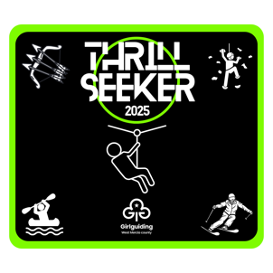

**Kit list for Thrill Seeker**

Please **attend in Girlguiding uniform** and bring a packed lunch and refillable water bottle in a rucksack or backpack so it can be carried around with you if needed.

Please attend the event in trousers, shorts must be knee length, with comfortable outdoor shoes and your hair tied back.

* Full change of clothes for going on the water including shoes (no flip flips, wellies, or crocs)
* A long-sleeved t-shirt or jacket for archery
* Weather dependant, a waterproof coat, sun hat, sun cream
* Some spending money for the tuck shop
* A sitter
* Spare hair ties
* Lunch (No nut products)

Don’t forget any medication that might be needed during the event.

This must be named and details on the health form.

**Leaders**

* A cup for hot drinks
* A camping chair if required
* Basic first aid kit
* Lunch

Please leave anything of value at home!

**\*Girlguiding West Mercia and Girlguiding UK accepts NO responsibility for damage or loss to any personal property including but not limited to; mobile phones, air pods, sports watches, cameras, ipads.\***